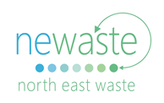

MEDIA RELEASE

Registrations open for Second Hand Saturday

If a good spring clean is on your agenda this year, then put Saturday 28 September in your calendar and get ready for the North Coast’s biggest day of garage sales - Second Hand Saturday!

Hosted by Council and North East Waste, registrations have just opened for the 2019 event, giving you plenty of time to decide what you no longer use and could turn into cash.

Coordinator of Second Hand Saturday, Linda Tohver said “with over 800 registrations last year, the popular community event has become a yearly prompt for many to start their annual de-clutter and reduce what is sent to landfill.”

“The event provides a great opportunity to bring the community together and put all those items no longer needed or used by one person, back out on display to be used again by someone else. As they say - one man’s trash is another man’s treasure.”

This year will mark the 11th time Second Hand Saturday has run since it began in 2005.

So why register for Second Hand Saturday? Apart from free advertising of your sale, it’s the biggest garage sale event to involve Tweed, Byron, Ballina, Kyogle, Lismore, Richmond Valley and the Clarence Valley, attracting enthusiastic treasure hunters from all around.

“We always encourage people to join forces with their local community to attract more attention - get your neighbours involved and hold a street sale, run a fundraiser or collate your efforts at your local club, school or church. That’s just one of our tips for the day to get the crowds to your sale!” Linda says.

“Plus if you think you have too much for just one day, there’s an optional second date the following Saturday 5 October for those who participate on the first date. Just select this option during registration.”

For more information and to register, visit secondhandsaturday.com.au, like the mysecondhandsaturday Facebook page or phone your local council.

Second Hand Saturday is coordinated by North East Waste and Council, funded by the NSW EPA's Waste Less Recycle More initiative.

Ends

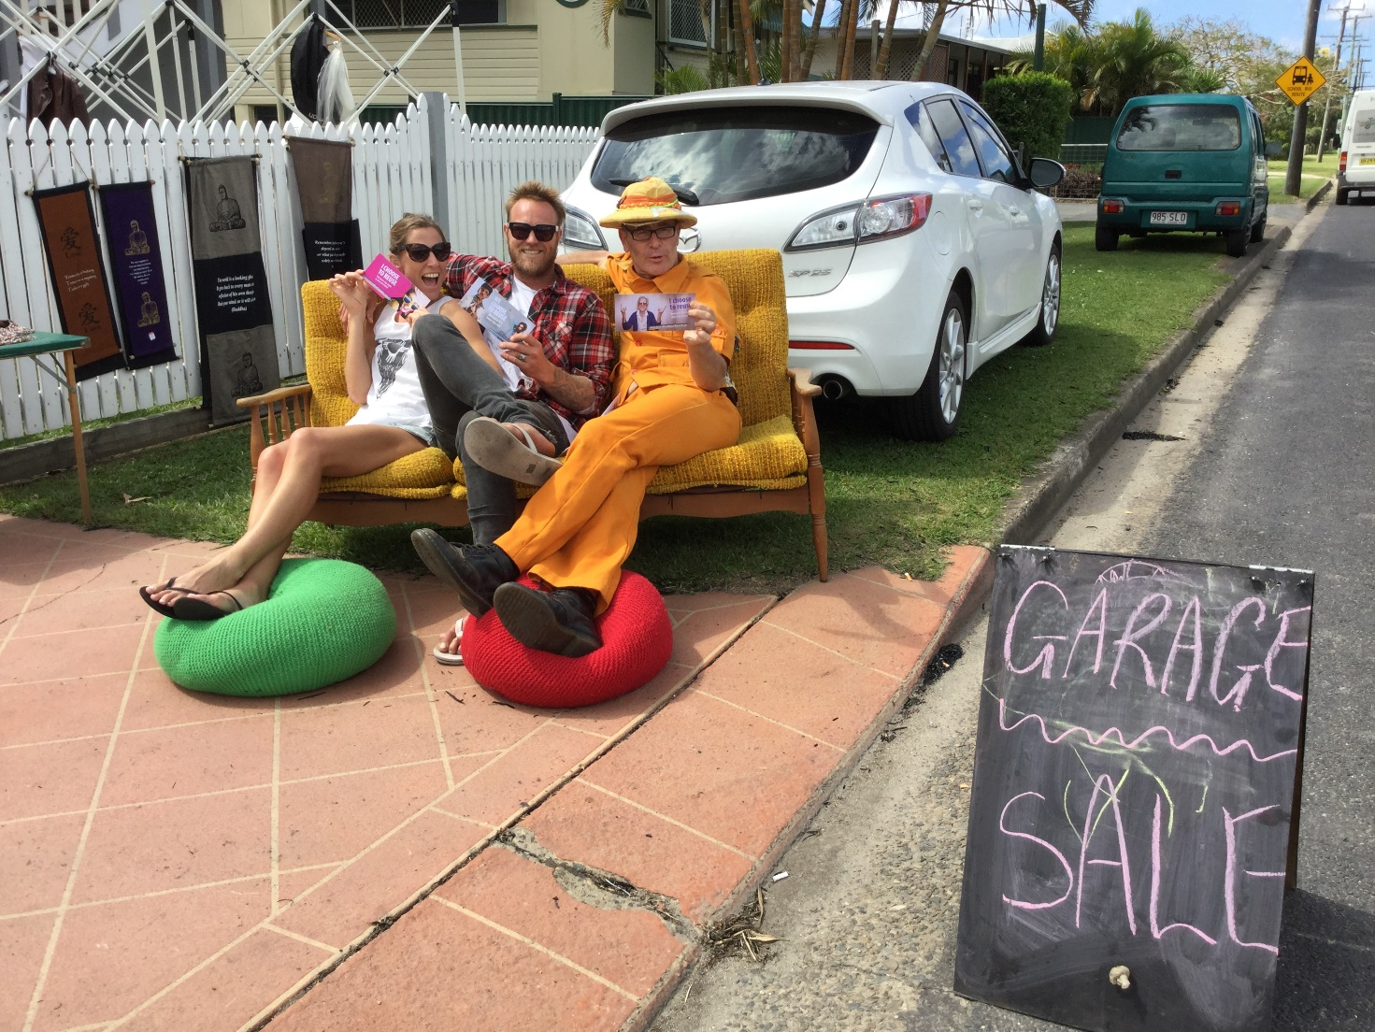
Photo caption: Gearing up for Second Hand Saturday 2019, our Wipe out Waste team is predicting another giant #garagesale day!

Contact: Linda Tohver
North East Waste Education Coordination
www.newaste.org.au
E: linda@newaste.org.au
P: 0427 770 198

